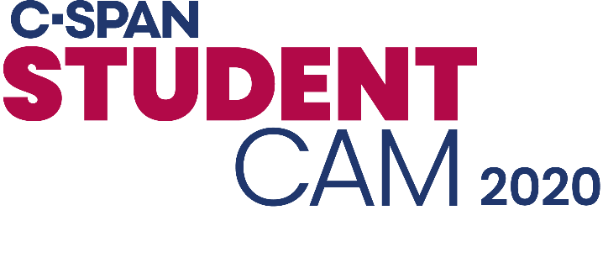 CABLE LOGO

Dear (GOVERNMENT OFFICIAL),
On its 16th year, (Cable) partners with C-SPAN on StudentCam, their annual documentary competition, where C-SPAN recently announced (#) winning students in (CITY). Students were asked, “What's your vision in 2020? Explore the issue you most want presidential candidates to address during the campaign." These students challenged themselves on issues of national significance and we are thrilled to celebrate our local winners.

This is a great opportunity to recognize our winners publicly and allows you to acknowledge their accomplishments. Celebrating your winners via social media post, newsletter, sending them a certificate of recognition or making a proclamation encourages these students to continue making their voices heard.
(CABLE) congratulates:
(STUDENT NAMES)
(SCHOOL, GRADE)
(PRIZE LEVEL, PRIZE MONEY)
(LINK TO VIDEO)
[If Grand, First, or Second prize winner: (TEACHER NAME) will also receive (PRIZE MONEY)].

Since the competition began, C-SPAN has given more than $1,000,000 to students and teachers around the country. C-SPAN awards a total of 150 winning videos and 53 faculty advisors prizes totaling $100,000. The annual competition is sponsored by C-SPAN Classroom, a free membership service dedicated to supporting educators' use of C-SPAN programming and websites. C-SPAN's general operations are funded by (CABLE).

Viewers in our community can watch all the winning videos anytime at www.studentcam.org. [If you have Grand, First, or Second prize winner: Additionally, (CABLE) is offering (WINNING STUDENT'S) video on Video on Demand through (DATE).] If you have any questions about StudentCam, please email educate@c-span.org.

Thank you,
(CONTACT INFO)

For more information about C-SPAN Classroom, C-SPAN's free membership service for civics and government educators, visit www.c-span.org/classroom.

